**ECON90080 – Assignment 2**

**Josh Copeland (SID: 1444772)**

**Question 1**

1. **Plot log-differenced series of the different consumption time series and state how each series co-moves with GDP.**

Chart 1 shows that:

* All three categories of consumption move pro-cyclically with GDP growth.
* Durables are clearly the most volatile with the largest fluctuations, which blow out particularly during recessions (COVID, the Great Recession, etc).
* Services are the most stable of the three consumption components, which nondurables slightly more volatile (far closer to the volatility of services than durables).

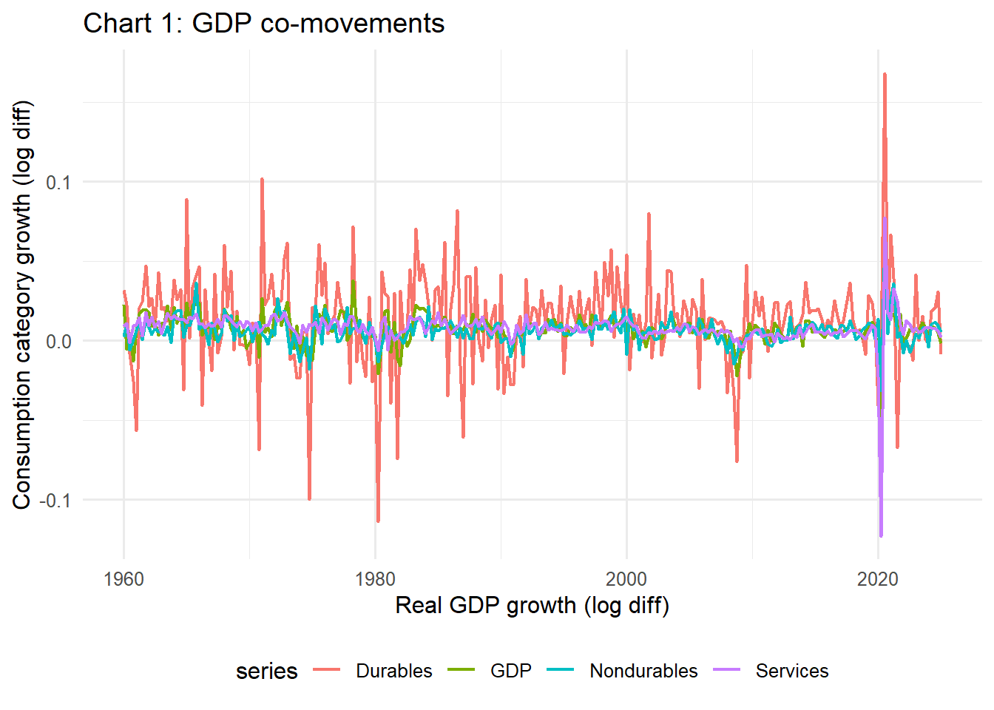

1. **Compute the standard deviation of each series. State what this tells you about the volatility of each relative to GDP and provide some intuition for your response.**

Table 1 computes the standard deviation of each time series in descending order. It indicates:

* Durables consumption is almost three times as volatile as GDP, reflecting the fact household are able to more easily delay the purchases of durables - it is not a necessity.
* Services and nondurables are much steadier, with volatility close to or below GDP, reflecting these categories cover necessities (such as groceries) which households cannot delay.

*Table 1: Standard deviation (SD) of time series*

|  |  |
| --- | --- |
| Series | SD |
| Durables | 0.0302 |
| GDP | 0.0106 |
| Services | 0.0106 |
| Nondurables | 0.00848 |

1. **Calculate cross-correlations of each consumption spending category with GDP for lags 0 to 3. State which series is a leading indicator of GDP.**

Table 2 summarises the cross-correlation of each time series with GDP. It indicates:

* Only durables and nondurables consumption could possible be classified as a leading indicator of GDP by virtue of non-zero lag values in table 2 being meaningfully positive. For durables, this leading property is strongest at lag 1 (0.26) and at lag 2 for nondurables (0.23). However, it should be pointed out these values aren’t particularly large in absolute terms.
* Services cannot be conceived as a leading indicator in any sense as all non-zero lag values are very close to zero.

*Table 2: GDP cross-correlations*

|  |  |  |  |  |
| --- | --- | --- | --- | --- |
| Series | Lag | | | |
| 0 | 1 | 2 | 3 |
| Durables | 0.55 | 0.26 | 0.12 | 0.05 |
| Nondurables | 0.62 | 0.07 | 0.23 | 0.06 |
| Services | 0.72 | -0.04 | 0.02 | 0.05 |

**Question 2**

1. **Using the matching function , where is matching efficiency and is the elasticity of the matching function with respect to the unemployment rate , denote as an expression for labour market tightness and write down an expression for the job-finding rate in terms of and parameters of the matching function.**

The job-finding rate of defined as the number of matches per unemployed worker:

Once we substitute on our matching function we get:

Now we can substitute in our expression for labour market tightness whereby by inverting the original expression given in the question:

Now everything is in terms of and we just need to simplify this expression. Do this by expanding the denominator:

1. **Assume and . Given data on the level of unemployed and vacancies, compute the job-finding rate, . Plot the job-finding rate over time.**

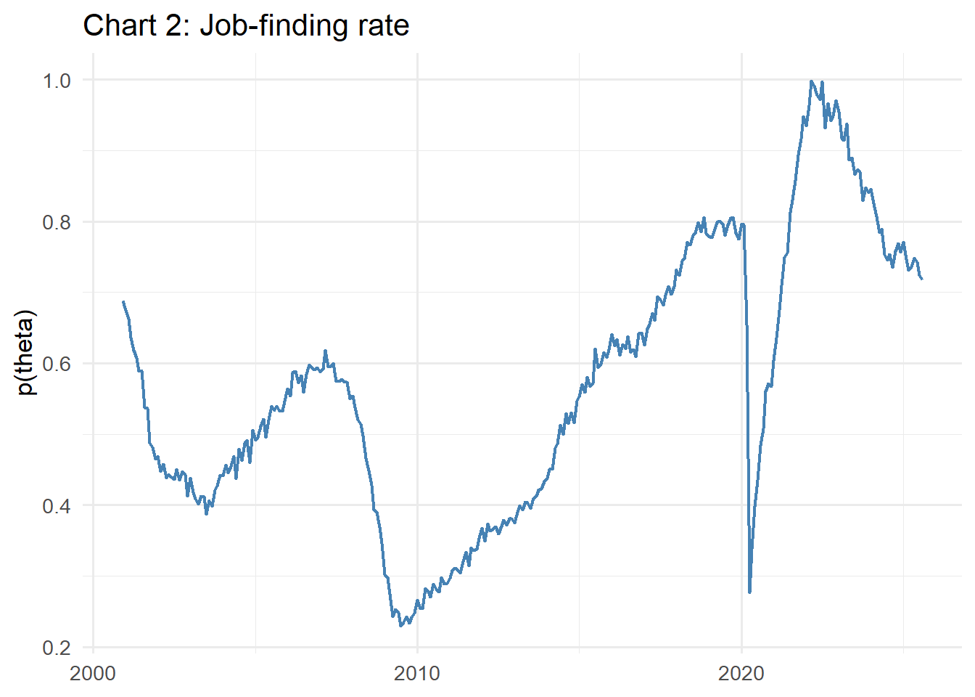

1. **Write down an equation characterising the law of motion of the unemployment rate. Chart how it compares to the actual unemployment rate observed in the data.**

Tomorrow’s unemployment rate can be characterised as today’s unemployment rate plus the net impact of flows in and out of unemployment. More technically:

Where is today’s unemployment rate and is the separation rate. This can be simplified further:

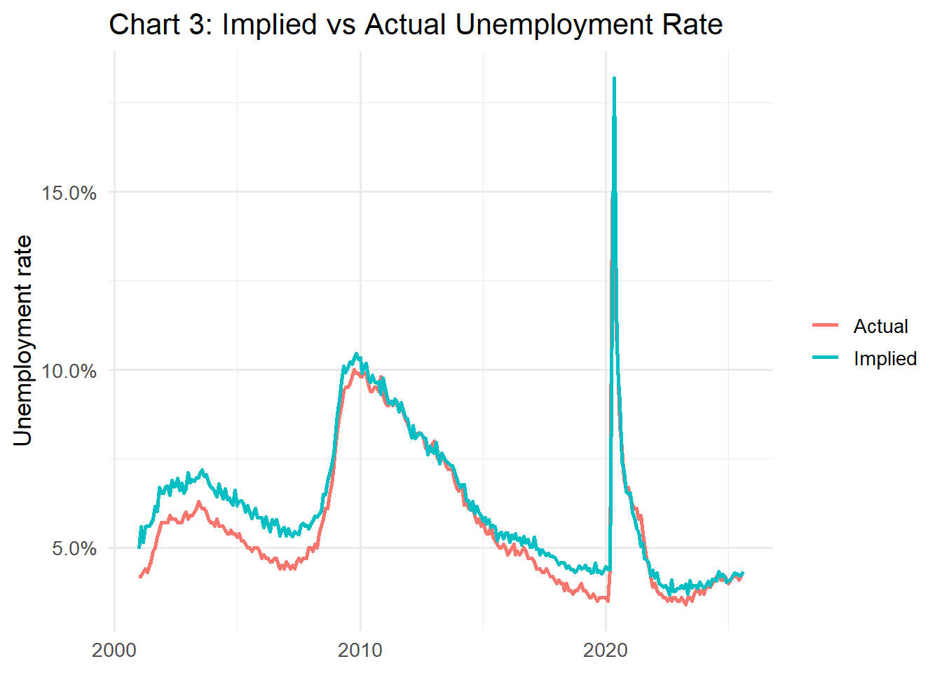

1. **How well does the implied unemployment rate series line up against the actual unemployment rate? Provide some brief intuition as to why there might be discrepancies (if any) between the two series.**

Chart 3 above indicates the implied and actual unemployment rates. It shows:

* The implied and actual unemployment time series line up pretty closely and captures the main cyclical movements observed during the Great Recession and COVID-19 outbreak. However, the implied unemployment rate seems to hover persistently above stable periods in the labour market: the beginning of the 21st century until the Great Recession and towards the end of the 2010s.
* These periods of over-predicting the unemployment rate during stable periods in the labour market is likely explained by the matching function having fixed parameters . It’s possible in reality that the following could generate a lower unemployment rate during periods of strong labour market outcomes:
  + Matching efficiency could be higher when the labour market is tighter, meaning more unemployed workers are matched into jobs for quickly.
  + The sensitivity of matches to vacancies could be higher when the labour market is tighter, amplifying the responsiveness of job finding to vacancy growth.

**Question 3**

1. **Set up the household problem and derive the household’s optimality conditions**

The household problem can be characterised as:

Which can be rewritten as the following Lagrangian:

Taking FOCs:

The first optimality condition is ’s FOC as the household lifetime budget constraint. The second is the Euler equation, defined by equating the first two FOCs:

1. **Set up the firm’s problem and derive its optimality conditions.**

The firm’s problem can be characterised as:

Taking FOCs:

1. **Suppose N = 1, α = 0.5. Solve for ℓ.**

We begin by substituting the Euler equation into the Budget constraint:

We can begin solving for this expression by developing using the given constraints from the firm’s FOCs:

Now we simply multiply it by a:

Therefore:

Now we can simplify using our market clearing assumptions :

Therefore:

1. **Consider now a social planner who wants to maximize the utility of households given the resources in the economy. Note that unlike the individual household in the market economy, the social planner can tell all households how much they should work. Set-up the social planner’s problem and derive the planner’s optimality conditions**

The social planner chooses aggregate consumption and aggregate labour supply to maximise everyone’s utility and is constrained by aggregate production. It’s problem can be formally characterised as:

Which can be expressed as the following Lagrangian:

Taking FOCs:

The labour FOC can be simplified further using the consumption FOC :

And by using the resource constraint

The consumption FOC is the first optimality condition, whereas this simplified labour FOC is our second.

There is also the final feasibility constraints FOC: